Hadoop MapReduce Word Count on Multiple Files

1. Objective
To create an HDFS directory, upload multiple text files, perform Word Count using Hadoop MapReduce on all files collectively, and identify the top 3 most frequent words from the generated output.

2. Procedure

Step 1: Create a Directory in HDFS
hdfs dfs -mkdir /my_data_directory

Step 2: Create Three Text Files Locally
echo "This is the content of file1.txt" > file1.txt
echo "This is the content of file2.txt" > file2.txt
echo "This is the content of file3.txt" > file3.txt

Step 3: Upload the Files to HDFS
hdfs dfs -put file1.txt /my_data_directory/
hdfs dfs -put file2.txt /my_data_directory/
hdfs dfs -put file3.txt /my_data_directory/

Step 4: Verify the Uploaded Files

List Files in the Directory
hdfs dfs -ls /my_data_directory

View File Contents
hdfs dfs -cat /my_data_directory/file1.txt
hdfs dfs -cat /my_data_directory/file2.txt
hdfs dfs -cat /my_data_directory/file3.txt

Step 5: Execute the Word Count Program
hadoop jar $HADOOP_HOME/share/hadoop/mapreduce/hadoop-mapreduce-examples-*.jar wordcount /my_data_directory /wordcount_output

Step 6: View the Word Count Results
hdfs dfs -cat /wordcount_output/part-r-00000

Step 7: Find the Top 3 Most Frequent Words
hdfs dfs -cat /wordcount_output/part-r-00000 | sort -t$'\t' -k2 -nr | head -3

3. Source Code

Create HDFS Directory
hdfs dfs -mkdir /my_data_directory

Create Input Files
echo "This is the content of file1.txt" > file1.txt
echo "This is the content of file2.txt" > file2.txt
echo "This is the content of file3.txt" > file3.txt

Upload Files to HDFS
hdfs dfs -put file1.txt /my_data_directory/
hdfs dfs -put file2.txt /my_data_directory/
hdfs dfs -put file3.txt /my_data_directory/

Verify Uploaded Files
hdfs dfs -ls /my_data_directory

hdfs dfs -cat /my_data_directory/file1.txt
hdfs dfs -cat /my_data_directory/file2.txt
hdfs dfs -cat /my_data_directory/file3.txt

Execute Word Count
hadoop jar $HADOOP_HOME/share/hadoop/mapreduce/hadoop-mapreduce-examples-*.jar wordcount /my_data_directory /wordcount_output

View Results
hdfs dfs -cat /wordcount_output/part-r-00000

Get Top 3 Most Frequent Words
hdfs dfs -cat /wordcount_output/part-r-00000 | sort -t$'\t' -k2 -nr | head -3

4. Screenshots
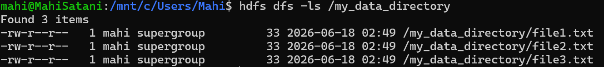
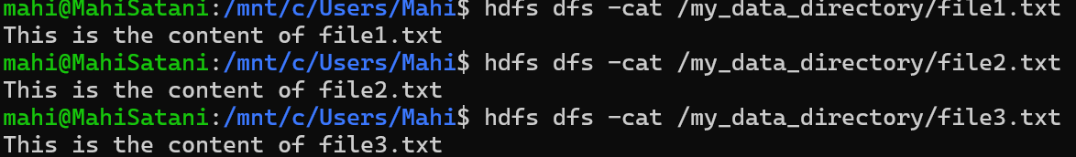
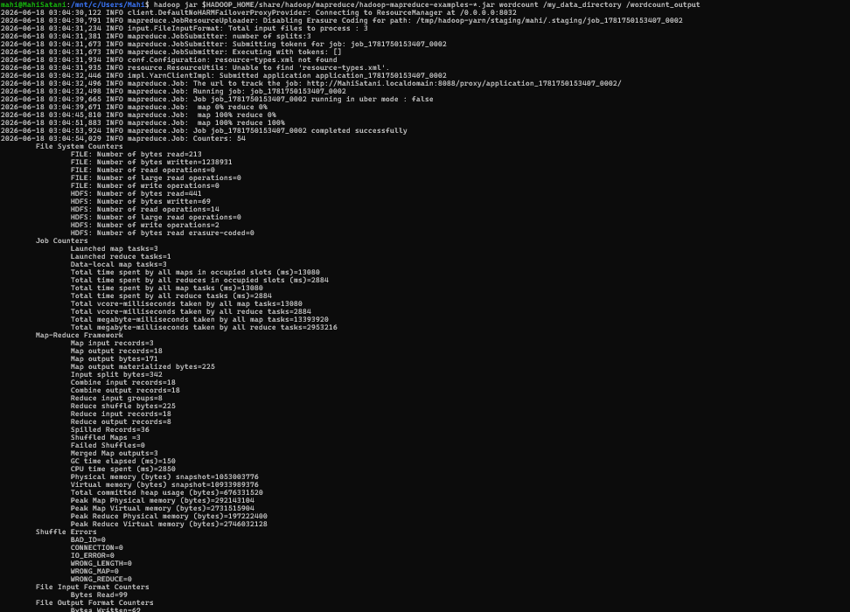
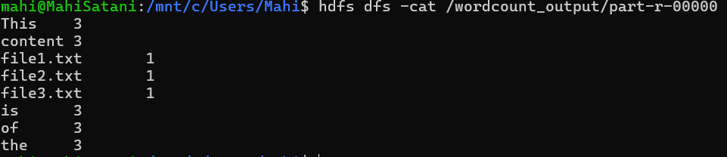

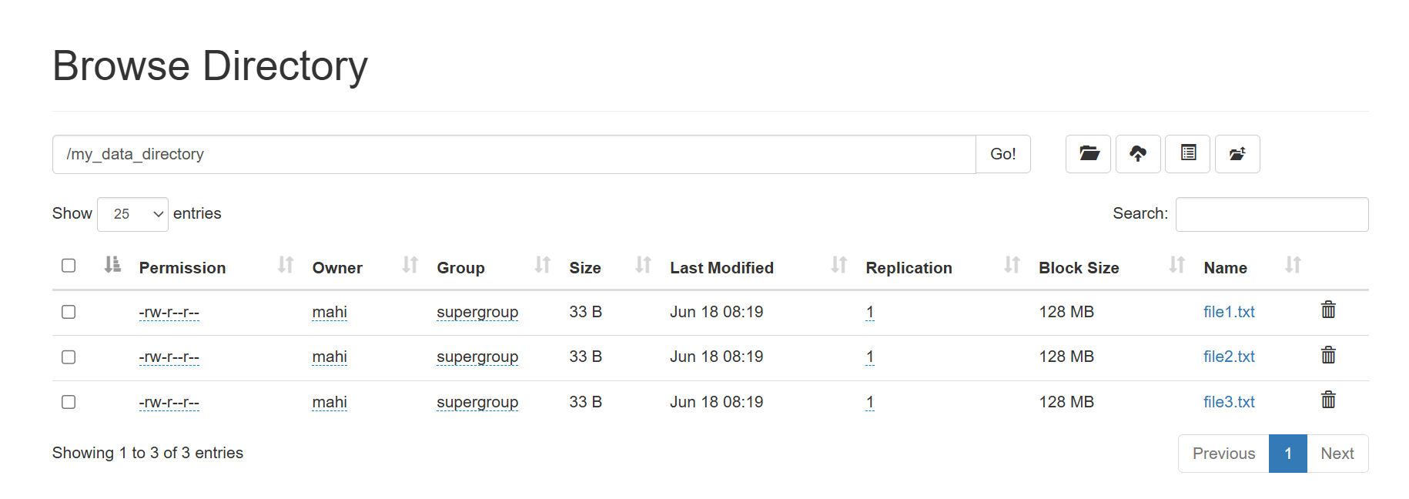

5. Conclusion
The experiment successfully demonstrated Hadoop MapReduce processing on multiple input files stored in HDFS. Three text files were uploaded into an HDFS directory and processed collectively using the Word Count application. The generated output provided the frequency of each word across all files, and Linux commands were used to identify the top three most frequently occurring words. This experiment illustrates Hadoop's capability to process data distributed across multiple files efficiently.

